Day 22 Emp_ID : 1129161646

Task1
What are the differences in good code and bad code

✅ What Makes Code Good?

1. Readability
- Uses clear, descriptive names for variables and functions.
- Proper spacing, indentation, and formatting make it easy to scan.
- Comments explain why a decision was made, not what the code does.
2. Simplicity
- Each function or class does just one job—no mixing tasks.
- Avoids unnecessary complexity or clever tricks.

3. Maintainability & Modularity
- Code is broken into small, focused units (components or modules).
- Each part is loosely coupled—changes in one area don’t break others.

4. Reusability & DRY (Don’t Repeat Yourself)
- No copy-pasting; shared logic is kept in a single location.
- Updates happen in one place—cleaner and less error-prone.

5. Robustness & Testability
- Anticipates invalid input and handles errors gracefully.
- Has automated tests (like unit tests) to verify behavior and prevent regressions.

6. Efficiency
- Uses smart algorithms and appropriate data structures.
- Avoids premature optimization but keeps performance in mind.

7. Consistency & Standards
- Follows coding conventions (style guides, naming rules).
- Easier for teams to collaborate, review code, and onboard new developers.

❌ What Makes Code Bad?

1. Poor Readability
- Uses vague names or inconsistent formatting.
- Excessive or unclear comments; hard to follow.

2. Excessive Complexity & God Classes
- Large classes or functions that do many things.
- Deep nesting and convoluted logic make understanding behavior difficult.

3. Low Cohesion & High Coupling
- Classes mix unrelated functionality.
- Parts of the code are tightly interdependent—changes have ripple effects.

4. Duplication & Violating DRY
- Same logic repeated in multiple places.
- Bugs or changes have to be fixed in multiple spots.

5. Lack of Testing & Fragility
- Few or no automated tests.
- Code breaks easily and bugs are hard to diagnose.

6. Poor Error Handling
- Hides exceptions or handles them too generically.
- The system fails without clear errors or simply crashes.

7. Too Many Comments or None
- Either comments that restate code, or no comments at all.
- Can obscure intent or confuse readers.

8. Spaghetti Code / Muddy Legacy Code
- Messy, tangled flow—often with hacks, redundant code, or unstructured design.
- Hard to maintain or extend.

Good code is clean, modular, efficient, and easy to understand. Bad code tends to be messy, tightly coupled, poorly tested, and error-prone. Ultimately, writing high-quality code saves time, reduces bugs, and makes future enhancements more reliable
Task 3

🔄 What Is Data Binding?
Data binding is a technique that automatically connects the UI (like text boxes, labels, or lists) with the underlying data model. When you bind a UI element to a data property:
- If the data model changes, the UI updates automatically.
- If the user edits the UI, the data model is updated automatically.

✅ Why Data Binding Matters

1. Less Manual Code
You don’t have to write code to sync UI with data or vice versa—it happens automatically.

2. Cleaner Architecture
UI code stays separate from business logic. This makes scenarios like testing or adapting UI easier.

3. More Reactive Interfaces
When the data changes, the UI reflects it immediately—making apps feel more dynamic and responsive.

Task 4

Continuous development means automating builds, tests, and deployment so your software is always integration‑ready or deployable. It delivers faster releases, higher code quality, better collaboration, and less risk—making it a cornerstone of modern DevOps teams.

Why Choose Continuous Development?

1. Faster Releases
Because every change goes through automation, software can be released more frequently—sometimes multiple times a day. Updates reach users much faster.

2. Better Code Quality
Automated testing runs on every change. Bugs are found early, reducing defects in the final product

3. Easier Collaboration
Teams share a constantly updated codebase. Everyone sees changes immediately—reducing merge conflicts and improving coordination
4. Less Risk
Releases are smaller and more frequent—so if something breaks, it's easier to trace and fix. Rollbacks are simpler too.

5. Efficient Feedback
Faster testing and deployment means quicker feedback—teams can adapt and iterate faster.

6. Automation & Productivity
Automating repetitive tasks—like builds, tests, deployments—lets developers focus on writing new features.

Task 5

Condition 1: Inheritance or Interface
You need a superclass or interface and at least one subclass that inherits from it.
- The superclass defines a method.
- The subclass inherits and overrides it.
class Animal {
void speak() {
System.out.println("Animal speaks");
}
}
class Dog extends Animal {
@Override
void speak() {
System.out.println("Woof!");
}
}

Here, Dog extends Animal, fulfilling condition 1.

Condition 2: Method Overriding (Same Signature)
The subclass must override the method from the superclass, using the same method name, parameters, and return type.

Condition 3: Upcasting (Superclass Reference)
You must refer to a subclass object using a variable of the superclass (upcasting).
Animal a = new Dog();

Even though a is declared as Animal, the actual object is Dog

Condition 4: Dynamic Binding (Runtime Decision)
When calling the overridden method via the superclass reference, Java decides at runtime which method to call—based on the actual object type, not the reference type.
Example:
Animal a = new Dog();
a.speak(); // Outputs: Woof!

Here, Dog’s version of speak() runs, thanks to dynamic binding.

Inheritance: Cat extends Animal
Overriding: Cat provides its own speak()
Upcasting: Animal pet = new Cat()
Dynamic binding: pet.speak() runs Cat’s method

Task 6

import org.junit.jupiter.api.Test;
import static org.junit.jupiter.api.Assertions.assertEquals;

public class JunitTest01 {
String message = "hello all How are you";
@Test
void testMsg() {
System.out.println("asserting the Test case ");
assertEquals("hello all How are you", message);
}
}

Task 7

import org.junit.jupiter.api.Tag;
import org.junit.jupiter.api.Tags;
import org.junit.jupiter.api.Test;

class TestCase02 {

@Test
@Tags({ @Tag("firstPriority") })
void testMethod01() {
// runtime logic yahan
}

@Test
@Tag("firstPriority")
void runTestcase02() {
// runtime logic yahan
}

@Test
@Tags({ @Tag("fastTag") })
void testMethod03() {
// runtime logic yahan
}

@Test
@Tag("slowTag")
void runTestcase04() {
// runtime logic yahan
}
}

Task 8
import org.junit.jupiter.api.Test;
import static org.junit.jupiter.api.Assertions.assertEquals;

public class Task8 {

@Test
void compare_firstGreater_returnsOne() {
Task8Logic obj = new Task8Logic();
int value = obj.compare(20, 10);
assertEquals(1, value); // Expected result = 1
}

@Test
void compare_secondGreater_returnsMinusOne() {
Task8Logic obj = new Task8Logic();
int value = obj.compare(5, 15);
assertEquals(-1, value); // Expected result = -1
}
}

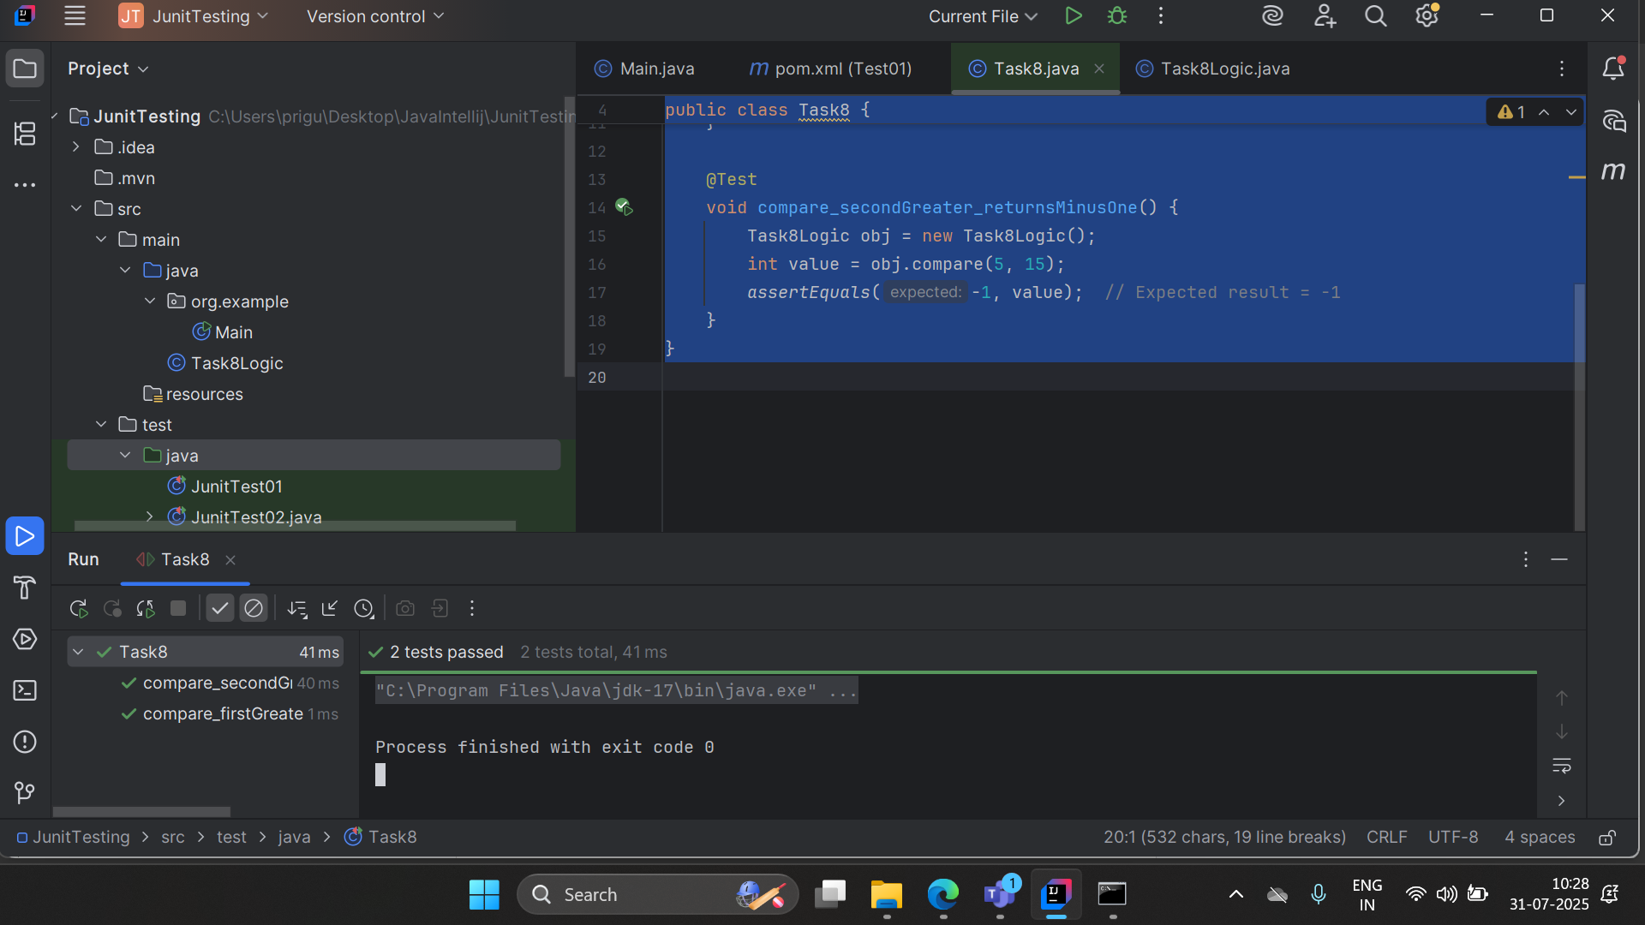

Task 9
public class Task8Logic {
public int compare(int n1, int n2) {
if (n1 > n2) return 1;
return -1;
}
}

